Paradise Ponies, Inc.  dba  Carousel of Aloha  Proud Fiscal Sponsor  of the  Hilo Lei Day Festival  Carousel of Aloha,  P.O. Box 1199, Hilo, HI 96721  Phone: 1-808-895-0850  e-mail: Info@LeiDay.org | 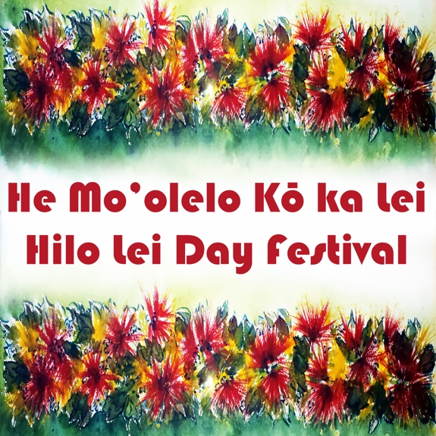

Aloha kākou!

It was so lovely meeting you at the Merrie Monarch craft fair. You have beautiful work, and we appreciate your interest in joining us at the Hilo Lei Day Festival. One of our goals is to support Hawaiʻi Island producers and makers. Please visit our website, LeiDay.org, to learn more of what we do. So, on to the answers you've been waiting for!

- Vendors shall wear aloha attire and lei, and are encouraged to participate in the group hula and singing, and encourage nearby visitors to do the same
- $60 fee for booth space, which includes the County of Hawaiʻi fee. Please pay via our Go Fund Me page: GoFundMe.com/LeiDay2018.
- Vendor locations are determined by the organizers of the event.
- Vendors may begin setting up any time after noon on 30 April, but must provide their own security for the night. Vendors must provide their own tents, tables, chairs. There is no electrical power to any of the spaces.
- Vendors must be ready by 8:30 am on 1 May
- All items sold must be made/grown on Hawaiʻi Island
- Vendors providing food service to the public are responsible for acquiring a Food Handling Permit from the Department of Health
- The permit must be posted at the booth during the event
- All standards and requirements of the Department of Health and the Fire Marshall must be met
- All vendors must submit a completed County of Hawaiʻi Department of Parks and Recreation Vendor Permit and copy of General Excise Tax License with application. The $30 county fee is included in your $60 fee for booth space

I do hereby waive and release Paradise Ponies, Inc, and the Hilo Lei Day Festival, owners or management of the grounds or location where the event is held, and/or any other associated entities from any and all claims of personal injury, bodily injury, property damage, or other damages, losses, and/or death that may arise from participation in this event. I have read and understand the rules and guidelines as stated above.

Signature:___________________________________________ Date:______________________

